VIDBRIEF: YouTube Transcript Summarizer using Hugging Face Transformers (Natural Language Processing)

Aditya Yadav¹, Akash Patel², Bhavya Jain³, Neeraj Sahu⁴, Prof. Pawan Makhija⁵

¹B. Tech. student, Department of CSE-Data Science, Acropolis Institute of Technology and Research, Indore, India

²B. Tech. student, Department of CSE-Data Science, Acropolis Institute of Technology and Research, Indore, India

³B. Tech. student, Department of CSE-Data Science, Acropolis Institute of Technology and Research, Indore, India

⁴B. Tech. student, Department of CSE-Data Science, Acropolis Institute of Technology and Research, Indore, India

⁵Professor, Department of CSE-Data Science, Acropolis Institute of Technology and Research, Indore, India
Email address: adityayadavadityayadav210179@acropolis.in, akashpatel211095@acropolis.in,
bhavyajain210356@acropolis.in, neerajsahu210532@acropolis.in,
pawanmakhija@acropolis.in

Abstract: - With the rapid increase in online video content, platforms like YouTube have become major sources of information, entertainment, and education. This surge presents a challenge for users seeking concise information without watching lengthy videos. A YouTube transcript summarizer addresses this need by generating quick, accurate summaries from video transcripts, allowing users to grasp the core content efficiently. This project report details the development of a YouTube transcript summarizer tool, which automates the extraction, processing, and summarization of video transcripts to provide brief, coherent summaries. The core objective of the project is to design a user-friendly tool that delivers accurate summaries by leveraging natural language processing (NLP) techniques. The summarization process involves several steps: transcript extraction, text preprocessing, summary generation, and evaluation. The tool begins by extracting the transcript directly from a YouTube video (either through API access or from closed-caption files). The transcript data, typically unstructured and verbose, undergoes preprocessing, including noise removal, sentence segmentation, and tokenization. This step prepares the text for efficient summarization, removing unnecessary words, fillers, and irrelevant content.
Keywords—NLP, summarization, text, video, summary, tokenization, preprocessing, insights, deep learning .

I. INTRODUCTION
A YouTube transcript summarization project is valuable for enhancing accessibility, efficiency, and knowledge extraction from the vast amount of content on the platform. With millions of hours of video uploaded every day, finding relevant information in lengthy videos is time-consuming for users. Summarizing transcripts enables quicker access to essential points, making it easier for audiences to decide if the content meets their needs without watching the entire video.
For content creators and researchers, transcript summaries offer a streamlined way to analyze video trends, themes, and insights across multiple videos. This can facilitate content planning and optimize engagement strategies based on popular topics or trends. Additionally, transcript summaries contribute to improved SEO, as search engines can index concise summaries to help users find videos relevant to specific queries.
Moreover, summarization improves accessibility for users with hearing impairments or non-native speakers, offering an easier way to consume information. With advances in natural language processing, automating transcript summarization can be efficient and scalable, providing succinct summaries in real-time or post-upload. Overall, a YouTube transcript summarization project serves as a beneficial tool for users, creators, and businesses alike, making YouTube content more accessible, discoverable, and user-friendly.

The purpose of a YouTube transcript summarizer is to provide users with a concise and easily digestible summary of a video's content without requiring them to watch the entire video or read the full transcript. With the vast amount of video content on YouTube, it can be time-consuming for viewers to sift through long videos to find key information. By summarizing the transcript, the tool helps users quickly understand the main points, topics, or arguments presented in the video. This can be especially useful for educational content, tutorials, lectures, or any informational videos where users want to save time or focus on specific segments. It also improves accessibility for people who prefer reading over watching or those with hearing impairments, offering a text-based way to engage with the content.The purpose of a YouTube transcript summarizer is to help users quickly grasp the main points of a video without having to watch the entire content.
Watching lengthy videos to extract key points can be time-consuming and inefficient. A YouTube Transcript Summarizer addresses this issue by automatically generating concise summaries of video transcripts, allowing users to grasp the main ideas without watching the entire video. The goal is to enhance the accessibility of YouTube content by enabling users to quickly understand lengthy videos without watching them in full.
II. OBECTIVES
The objective of the project is:
- Enhanced Accessibility: Provide summaries that make video content more accessible to people with hearing impairments, non-native speakers, or users with limited time, enabling them to understand the video’s key points quickly.
- Direct YouTube API Integration: The tool will integrate directly with the YouTube API to automatically fetch video transcripts, eliminating the need for manual input or copy-pasting.
- Improved Content Discovery: Enable users to more easily find relevant videos by generating search-friendly summaries, enhancing search engine optimization (SEO) and helping content reach a wider audience.

- Efficient Content Analysis for Creators and Marketers: Offer creators a tool to quickly review and analyze their content or trends across videos, which can inform future content strategies and enhance viewer engagement.

- User Interface (UI) and Experience: The tool will develop a clean and intuitive interface where users can simply input a YouTube video URL, select the desired summarization options (length, style), and receive the output in seconds.

- Data-Driven Insights: Provide summarized data that can be used to extract insights, such as popular topics, frequently discussed themes, and viewer interests, which can support business and research initiatives.

III. LITERATURE SURVEY
“Summary and Keyword Extraction from Youtube video Transcript” this research paper was published by Shraddha Yadav, Arun Kumar Behra, Chandra Shekhar Sahu, Nilmani Chandrakar that endeavors to utilize Characteristic Dialect Handling strategies in arrange to extricate both rundowns and noteworthy watchwords from video transcripts through extractive and abstractive summarization. Making rundowns of video transcripts can be a time-saving that comes about in effectively securing noteworthy and imperative data. This technique eliminates the have to be observe the whole video and can altogether decrease the exertion contributed.
In 2021, Ishitva Awasthi, Kuntal Gupta, Prajbot Singh Bhojal, Anand, and Piyush kumar published “Natural Language Processing (NLP) based Text Summarization - A Survey”. The methods utilized for Summarisation of writings are through both Extractive and abstractive strategies. The benefits include computation of sentence suggestions through analyzing the phonetic and measurable highlights. Each summarizing strategy has its specific use, but there's a disadvantage of this variability. It is inconceivable to decide which method ensures more efficiency.

“Review of automatic text summarization techniques & methods” was published in 2020 by AdhikaPramita, SupriadiRustad, Abdul Shukur, Affandy. Text summarization and systematic review methods have been utilized. However, a key limitation of the fuzzy-based approach is its inadequacy in addressing semantic challenges. Additionally, methods applied in extractive industries must address several existing gaps.

The common point in all the above summarization models and in our model is that their model will yield similar output to ours but with different methods like abstractive and extractive strategies.

IV. SYSTEM SPECIFICATIONS
A. Hardware Requirements
1. Processor: At least 1GHz of processing speed.
2. Memory: At least 1GB of RAM.
3. Storage: At least 5GB of Hard disk or similar storage device used.
4. GPU: Any integrated GPU with 128MB of memory or more.
5. Display: A screen with at least a resolution of 1280x720 pixels.
6. A stable Internet Connection with at least 1mbps of speed.

B. Software Requirements
1. OS: Windows 7, Mac OS 10.x or higher.
2. Language: Python 3.x .
3. IDE: Google Colab or Jupyter Notebook.
4. Browser: latest version of Chrome, Mozilla, Safari or Opera.

V. METHODOLOGY
This project offers an opportunity to apply advanced NLP techniques for both abstractive and extractive text summarization. It presents an engaging concept suitable for intermediate learners and serves as a refreshing side project for experienced professionals.
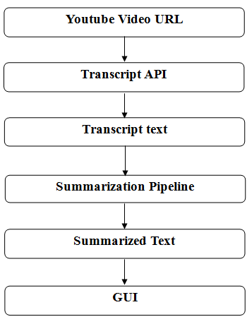
Fig. 1 Project Flow
Based on the described system architecture, the process begins by opening a YouTube video and clicking the "Summarize" button. Subtitles are retrieved using the YouTube-Transcript-API. Once the transcripts are obtained in text format, the system performs summarization. If transcripts are unavailable, the audio is extracted from the video, converted to text, and then summarized. The summarized transcript is displayed, followed by text translation using Python's Google Translation module. Additionally, users have the option to download a PDF of the summary for future reference.

A. Backend
The core functionality of the system is implemented using Python. Python provides a range of built-in libraries, such as the YouTube-Transcript-API, which is utilized to retrieve video subtitles. For text summarization, the system leverages Hugging Face Transformers to ensure efficient and accurate results.
B. Get Transcript
Uses an API called Youtube transcript API to fetch the transcripts for a given YouTube video.
C. Text Summarization
It is the process of reducing lengthy text into a shorter version while preserving its key ideas and overall meaning.
Two common approaches for text summarization are:
1) Extractive Summarization: This approach selects important sentences and phrases directly from the original text and presents them as the summary.
2) Abstractive Summarization: In this method, the model creates new sentences that convey the core ideas of the original text but in a more concise and rephrased form. For this project, Transformers will be utilized to implement this approach.
In this system, abstractive text summarization will be done on the transcript received in the previous phase using the Python Hugging Face module.

D. User Interface
A user interface is essential for enabling interaction between the user and the system. The interface is developed using technologies such as HTML and CSS, with Flask serving as the framework. This configuration provides a smooth and intuitive user experience.

VI. TECHNOLOGIES USED
A. NLP
Natural Language Processing (NLP) has enabled computers to understand and interpret natural language, much like humans do. By leveraging artificial intelligence, NLP takes real-world data—whether spoken or written—and makes sense of it in a way computers can process. Just as humans use their brains to analyze and understand information, computers rely on programs to achieve similar outcomes. Through this process, the input is transformed into a format that machines can read and comprehend.
B. Python
Python is a versatile, high-level programming language designed for general-purpose use. It features dynamic typing and automatic garbage collection. Python supports various programming paradigms, including structured, object-oriented, procedural, and functional programming, with a strong emphasis on the latter.
.
C. Text Summarization
Text summarization is the process of generating a clear, concise, and accurate summary from lengthy text content. The primary aim of automatic text summarization is to identify and extract the most essential information from a large text and present it in a format that is easy to understand. As the volume of online textual data continues to grow, automatic summarization techniques become increasingly valuable, enabling users to quickly access the most relevant information.

D. Hugging Face
Modern pretrained models can be easily accessed and utilized through the APIs and tools offered by Transformers. These models eliminate the need to train from scratch, saving significant time, computational resources, and reducing your carbon footprint. They support a variety of tasks across multiple modalities. Using the abstractive summarization technique, Hugging Face Transformers generate concise, original text that differs from the source while maintaining its meaning, creating entirely new sentences much like a human would.
E. Flask
Flask is a micro web framework built with Python. It is considered a microframework because it doesn’t require specific tools or libraries. Flask doesn’t include built-in components like a database abstraction layer or form validation, which are typically provided by third-party libraries. However, Flask is highly flexible and allows the use of extensions, enabling developers to add features to applications as if they were part of the core framework.

VII. RESULT

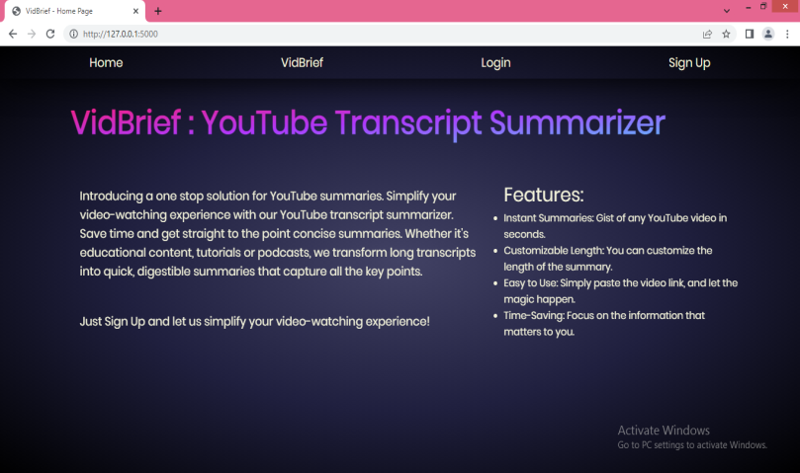

Fig. 2 Screenshot of Home page

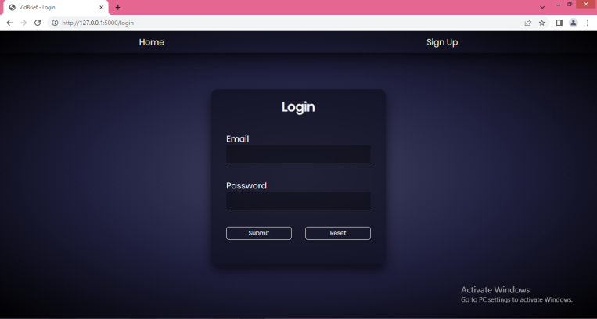

Fig. 3 Screenshot of Login page

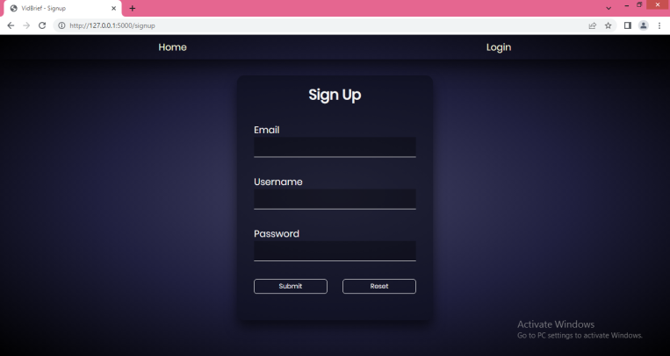

Fig. 4 Screenshot of Signup page

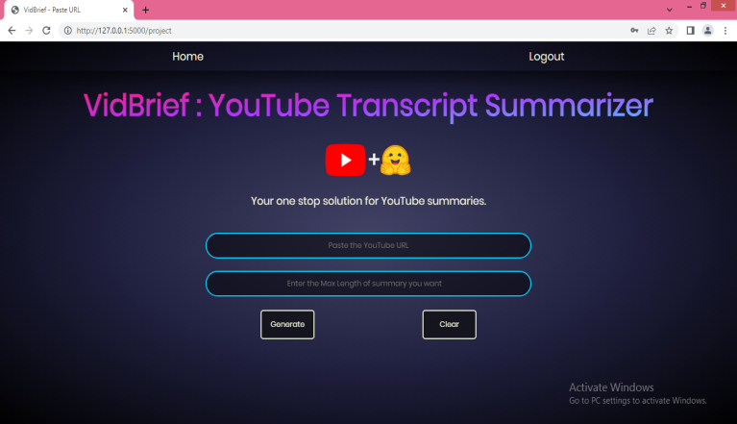

Fig. 5 Screenshot of the page where user enters the URL and the max length

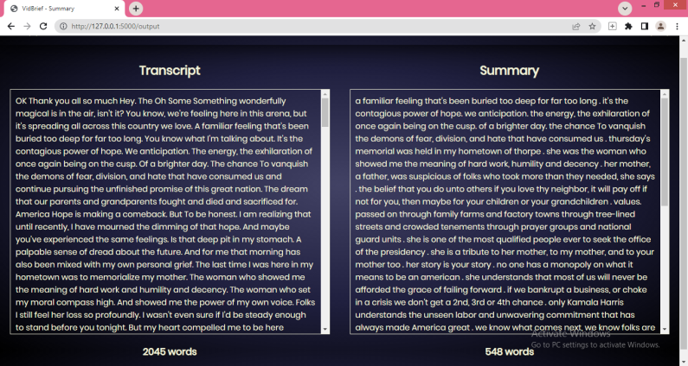

Fig. 6 Screenshot of the output summary and the transcript of the video

VIII. CONCLUSION
The project offers substantial benefits for improving accessibility, efficiency, and engagement with video content. By enabling users to quickly access key insights from videos, the summarizer allows for more efficient content consumption, which is especially valuable given the volume of content uploaded daily. This tool supports users with hearing impairments, and individuals with limited time, making YouTube content more inclusive and user-friendly.
For content creators and marketers, the summarizer provides valuable insights into trending topics and viewer preferences, enabling data-driven strategies and more targeted content planning. Additionally, by optimizing content for search engines with concise summaries, the summarizer enhances discoverability, helping creators reach broader audiences.
However, the project also faces challenges, such as handling transcription errors, ensuring contextual understanding, and addressing technical and ethical limitations. Despite these challenges, advances in natural language processing and machine learning can help address many of these issues, making transcript summarization a promising tool for the future of digital content interaction. Overall, this project is a valuable addition to the content ecosystem, with the potential to make video information more accessible, engaging, and impactful for a global audience.

IX. FUTURE SCOPE
The future of YouTube transcript summarization lies in leveraging deep learning, enhancing summarization systems, and fostering interdisciplinary research. Hence, it looks very promising and is likely to evolve significantly.

Educational Use:
- Students and Researchers:
A transcript summarizer can help students and researchers quickly review long educational videos, lectures, or webinars by extracting key information. It can condense hours of content into concise summaries, making it easier to study or reference material.

- Online Course Platforms:
Integrating the summarizer with online learning platforms (e.g., Coursera, Udemy) can offer students brief summaries of lengthy tutorial or course videos, helping them grasp core concepts faster.
- Quick Revision:
Summarized transcripts can be used by students for quick revision, allowing them to revisit the main points of a lecture without rewatching the entire video.

Business and Professional Use:
- Business Meetings and Webinars:
Professionals can use a YouTube transcript summarizer to review recorded meetings, webinars, or training sessions. It enables them to extract key takeaways or action points from long discussions without having to rewatch the entire meeting.

- Market Research:
Market researchers can use summaries to sift through large amounts of video content to analyze trends, consumer opinions, or competitor strategies efficiently.

Content Marketing and Social Media:
- Video Summaries for Blogs:
Video summaries can be repurposed as blog content or social media posts, where users can quickly generate an article-style summary of a video and share it to engage audiences who prefer text-based content.
- SEO and Metadata Generation:
A YouTube summarizer can help content marketers generate SEO-friendly descriptions, tags, and metadata based on the summarized content, improving video discoverability.

Content Discovery and Time-saving:
- Video Browsing:
Instead of watching long videos to determine their relevance, users can read brief summaries to decide if the video content is worth watching. This is useful for researchers, professionals, and casual viewers alike who want to maximize their time.
- Podcast and Long-Form Content Summaries:
For long-format content such as interviews, discussions, or podcasts uploaded to YouTube, summaries provide quick overviews of key points, helping users stay informed without committing extensive time to the entire video.

Personal Productivity:
- Time Management:
Busy individuals who want to stay informed can use the summarizer to condense self-help, productivity, or news videos into short summaries that fit into their schedules, allowing them to consume more content in less time.
- Learning on the Go:
People can use the summarizer to generate text-based versions of video content that they can read while commuting or multitasking.

Media and Journalism:

News and Event Summaries:

Journalists can use the summarizer to extract the key points from news broadcasts, speeches, or press conferences, allowing them to quickly report or write summaries for articles.

X. ACKNOWLEDGMENT
We want to convey our heartfelt gratitude to Prof. Pawan Makhija sir, our mentor, for his invaluable advice and assistance in completing our project. He was there to assist us every step of the way, and his motivation is what enabled us to accomplish our task effectively. We are also thankful to our Project In-charge Prof. Mayank Bhatt sir, Project Coordinator Prof. Deepak Singh Chauhan sir and Prof. (Dr.) Prashant Lakkadwala, HOD sir for his kind official support and encouragement. Many thanks go to the all lecturers and supervisors who have given their full effort in guiding the team in achieving the goal as well as their encouragement to maintain our progress in track.

REFERENCES

[1] Jiri Fajtl, Hajar Sadeghi Sokeh, Vasileios Argyriou , Dorothy Monekosso , and PaoloRemagnino: Summarizing Videos with Attention In: Proceedings of the ICLR. Vol. 5(2019).
[2] Kaiyang Zhou, Yu Qiao, Tao Xiang : Deep Reinforcement Learning for UnsupervisedVideo Summarization In: Diversity-Representativeness Reward 2018, Association for theAdvancement of Artificial Intelligence (www.aaai.org).
[3] Mrigank Rochan, Linwei Ye, and Yang Wang: Video Summarization Using FullyConvolutional Sequence Networks In: International Conference on LearningRepresentations (2018).
[4] Ferman A.M. and Tekalp A.M. Two-stage hierarchical video summary extraction tomatch low-level user browsing preerences. IEEE Trans. Multimedia, 5(2):244 – 256, 2003.

[5] P.Sushma, Dr.S.Nagaprasad, Dr. V. Ajantha Devi. Youtube: Bigdata Analytics usingHadoop and Map Reduce in International Journal of Engineering Research in ComputerScience and Engineering (IJERCSE), vol 5, Issue 4, April 2011.
[6] P. R. Dedhia, H. P. Pachgade, A. P. Malani, N. Raul and M. Naik, "Study on Abstractive Text Summarization Techniques," 2020 International Conference on Emerging Trends in Information Technology and Engineering (ic- ETITE), 2020, pp. 1-8, doi: 10.1109/ic-ETITE47903.2020.087.
[7] A. Dilawari and M. U. G. Khan, "ASoVS: Abstractive Summarization of Video Sequences," in IEEE Access, vol. 7, pp. 29253-29263, 2019, doi: 10.1109/ACCESS.2019.2902507.
[8] https://medium.com/swlh/parsing-rest-api-payload-and-query-parameters-with-flask-better-than-marshmallow-aa79c889e3ca
[9] https://www.crio.do/projects/python-youtube-transcript/
[10] https://pypi.org/project/youtube-transcript-api/
[11] https://www.thepythoncode.com/article/text-summarization-using-huggingface-transformers-python

[12] https://blog.miguelgrinberg.com/post/designing-a-restful-api-with-python-and-flask

